**Non-Invasive Assessment of Mesenteric Hemodynamics with 4D flow MRI**

1G Roberts; 2A Roldán-Alzate; 2CJ Francois; 1,2O Wieben

*Departments of 1Medical Physics, 2Radiology*

*University of Wisconsin – Madison, USA*

**Synopsis:** Chronic mesenteric ischemia (CMI) is a disease caused by inadequate blood flow to the intestines. This study investigates the use of 4D flow MRI to non-invasively assess the hemodynamics of mesenteric circulation in patients with CMI. Flow was measured in 9 vessels before and after meal challenges for 19 subjects suspected of CMI and 6 controls. Post-prandial flow increased significantly in the supraceliac aorta, superior mesenteric artery, superior mesenteric vein, and portal vein. The flow increase was drastically less in patients with CMI. This demonstrates the potential for 4D flow MRI in assisting the challenging diagnosis of CMI.

**Introduction:**

Chronic mesenteric ischemia (CMI) is caused by a blood flow reduction to the intestines. Around 90% of cases are the result of atherosclerosis, however, conditions such as median arcuate ligament syndrome (MALS), may also result in CMI1. Patients with CMI typically present with postprandial abdominal pain, occurring 15-60 minutes after a meal. Recurrent symptoms may result in noticeable weight-loss and fear of food. If left unrecognized, CMI has the potential to progress into life-threatening acute ischemia with bowel infarction1. Thus, an importance is placed on the accurate diagnosis of CMI. This has traditionally been accomplished by invasive interventional angiography and duplex ultrasonography, but evaluation and visualization of mesenteric vasculature can be difficult. 4D flow MRI has previously been proposed to anatomically and functionally evaluate mesenteric vasculature2,3. This abstract further expands on the use of 4D flow MRI for quantifying mesenteric hemodynamics and assessment of both portal venous and mesenteric circulation in the major vessels of the upper abdomen.

**Methods**: In this IRB-approved and patient-compliant study, 19 subjects (age range 21-86y, mean = 49y, females = 13) presenting with symptoms of mesenteric ischemia and 6 healthy subjects (age range 31-46y, mean = 39y, females = 2) were imaged on a 1.5T and 3.0T clinical scanner (GE Healthcare). 1 patient was rescanned before and after MALS surgery. For all subjects, 4D PC MR data were acquired before and after a meal challenge using 5-point PC-VIPR acquisition4,5 with full volumetric coverage of the upper abdomen: imaging volume: 32x32x24cm spherical; 1.25mm isotropic resolution; TR/TE = 6.4-8.4ms/2.2-2.5ms; intravascular contrast agent (0.03mmol/kg of gadofosveset trisodium (Lantheus, N. Billerica, MA)); with retrospective ECG and respiratory gating. Pre-prandial imaging was performed after 5 hours of fasting. After the first scan, subjects orally ingested 574 mL EnSure Plus® (Abbot Laboratories, Columbus, OH) and scanning was resumed 20 minutes after ingestion. 3D vessel segmentation from the PC data was performed using Mimics (Materialize, Leuven, Belgium). Ensight (CEI, Apex, NC) was used for plane placement, anatomical assessment, and flow visualization (Figures 1-2). Cut planes were placed in 6 arterial vessels: supraceliac aorta (SCAo), infrarenal aorta (IRAo), celiac artery (CA), superior mesenteric artery (SMA), right renal artery (RRA), and left renal artery (LRA). In addition, planes were placed in 3 portal vessels: splenic vein (SV), superior mesenteric vein (SMV), and portal vein (PV). These cut-planes were exported to a customized software package6 that allowed for manual temporal segmentation throughout the cardiac cycle. Hemodynamic parameters were then analyzed for each subject. Statistical analysis was performed using paired t-tests (between pre- and post-prandial states) as well as a two-sample t-test (between groups).

**Results:** 4D flow data were successfully obtained for all 25 subjects. In response to the meal challenge for the control group, flow in the SCAo increased on average by 18% (p = 0.010), SMA increased by 52% (p = 0.014), SMV increased by 59% (p = 0.003), and PV increased by 47% (p = 0.001) as seen in Figure 3. The ischemia group also saw average increases in flow: SCAo 6% (p = 0.078), SMA 18% (p = 0.026), SMV 40% (p = 0.00004), and PV 27% (p = 0.00012). In addition, there was a 14% decrease in the RRA flow values (p = 0.033). Cross comparing the flow difference between both groups showed a statistically significant difference in meal challege responses, specifically, the ischemia group showed less change in flow after a meal in the SCAo (p = 0.029, effect size = -1.079), SMA (p = 0.004, effect size = -1.48), SMV (p = 0.003, effect size = -1.533), and PV (p = 0.002, effect size = -1.657) (Figure 3). The other vessels measured (IRAo, LRA, RRA, CA, and SV) did not show statistically significant meal response differences.

**Discussion:** The control group showed a greater change in flow in response to the meal challenge, while the overall change in flow for the ischemia group was significantly less (Figures 4-5). This is most likely due to the intrinsic pathology that is preventing the vessels from supplying the appropriate amount of blood flow to the abdomen.

**Conclusion:** This study demonstrates the feasibility of using 4D flow MRI to non-invasively and comprehensively assess the functional response to a meal challenge in patients with possible mesenteric ischemia. Additionally, complete anatomical coverage of all mesenteric vessels could further aid in diagnosis. In summary, this tool can be used to quantitatively and qualitatively aid in the difficult diagnosis of mesenteric ischemia.

**References:**

1. Wilkins LR, Stone JR. Chronic mesenteric ischemia. *Tech Vasc Interv Radiol*. 2015;18(1):31-37. doi:10.1053/j.tvir.2014.12.005

2. KC Li, Hopkins KL, Dalman RL CS. Simultaneous measurement of flow in the superior mesenteric vein and artery with cine phase-contrast MR imaging: value in diagnosis of chronic mesenteric ischemia—work in progress. *Radiology*. 1995;194(2):327-330.

3. Roldan-Alzate A, Frydrychowicz A, Said A, et al. Impaired regulation of portal venous flow in response to a meal challenge as quantified by 4D flow MRI. *J Magn Reson Imaging*. 2015;42(4):1009-1017. doi:10.1002/jmri.24886

4. Gu T, Korosec FR, Block WF, et al. PC VIPR: A high-speed 3D phase-contrast method for flow quantification and high-resolution angiography. *Am J Neuroradiol*. 2005;26(4):743-749. doi:26/4/743 [pii]

5. Johnson KM, Lum DP, Turski PA, et al. Improved 3D Phase Contrast MRI with Off-resonance Corrected Dual Echo VIPR. *Magn Reson Med*. 2008;60(6):1329-1336. doi:10.1002/mrm.21763.Improved

6. Stalder AF, Russe MF, Frydrychowicz A, Bock J et al. Quantitative 2D and 3D phase contrast MRI: Optimized analysis of blood flow and vessel wall parameters. *MRM*. 2008;60(5):1218-1231.

7. Hohenwalter EJ. Chronic Mesenteric Ischemia : Diagnosis and Treatment. 2009;1(212):345-351. doi:10.1055/s-0029-1242198.

**Figures:**

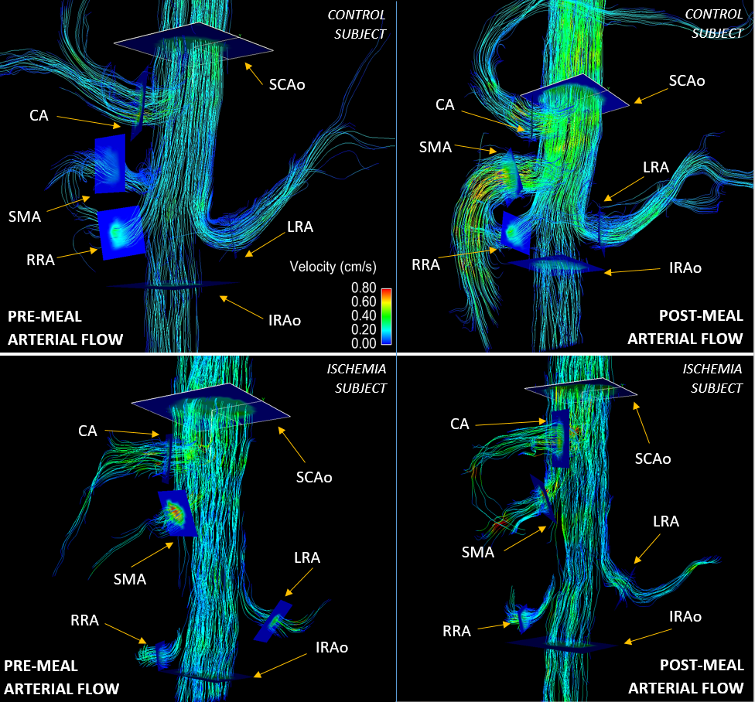

a)

b)

c)

d)

Figure 1: 4D Flow MRI streamline images for a control subject (figures a and b) and an ischemia subject (figures c and d) both before (figures a and c) and after a meal challenge (figures b and d). The colorscale for velocity and the number of streamline emitters are identical for all 4 images. Overall, this ischemia subject showed a reduced flow response after a meal.

b)

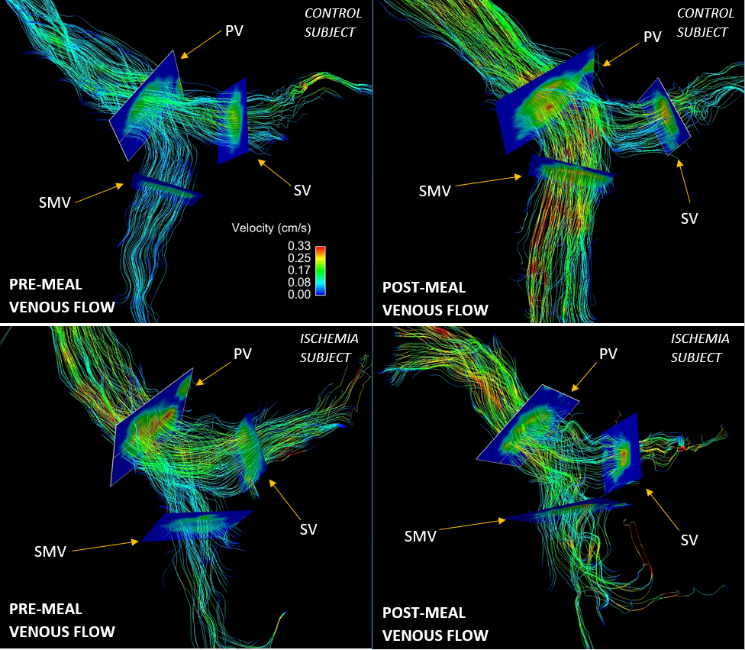

b)

d)

c)

a)

Figure 2: 4D Flow MRI data shown as streamline visualization of the venous system for a control subject (figures a and b) and an ischemia subject (figures c and d) both before (figures a and c) and after a meal challenge (figures b and d). The colorscale for velocity and the number of streamlines emitters are identical for all images above. There is a reduced flow response to the meal challenge in the ischemic cohort.

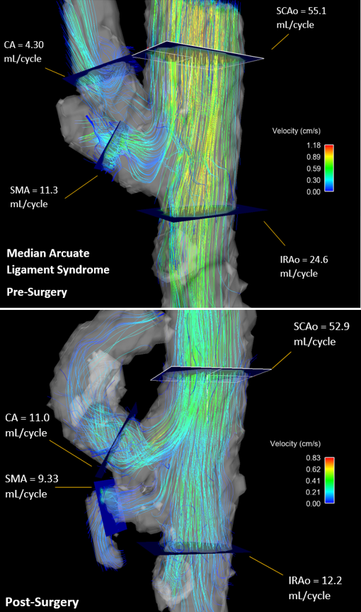

b)

a)

Figure 3: Patient diagnosed with median arcuate ligament syndrome (MALS). Images are shown before a) and after b) median arcute ligament release surgery. Image a) clearly shows disturbed flow, due to the pinching of the CA caused by the median arcuate ligament. Image b) shows post-surgery flow. Flow in the SMA increased by 488% and CA by 426% after surg

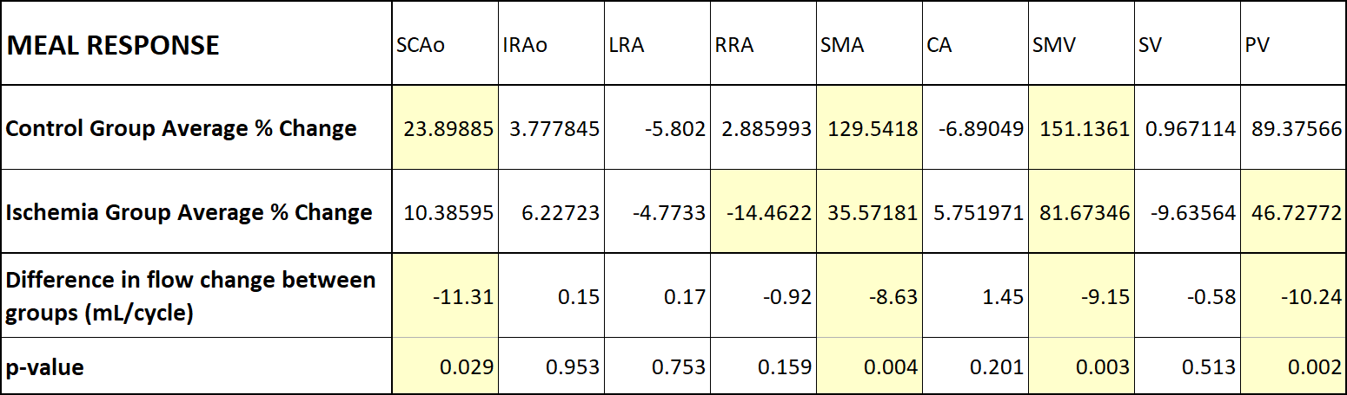

Figure 4: A two-sample t-test was performed on the change in pre- and post-meal flow values between both groups. Yellow indicates statistical significance in flow change. The control group showed an average blood flow increase in the SCAo, SMA, SMV, and PV. The ischemic group showed an average flow increase in the SMA, SMV, and PV as well as a decrease in flow in the RRA. There is less of an increase in flow in the SCAo, SMA, SMV, and PV for the ischemic subjects.

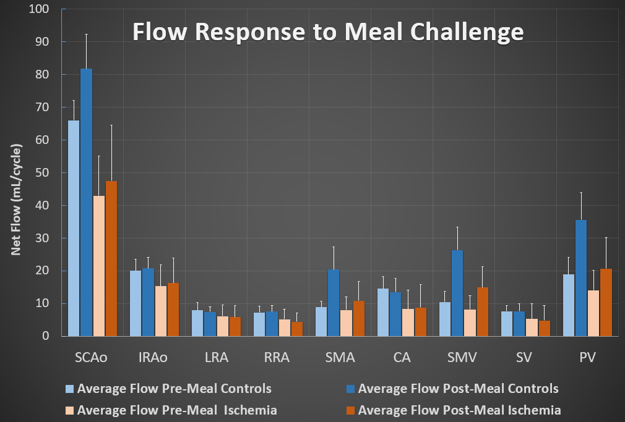

Figure 5: The bar graph above shows average blood flow for the ischemic group. Standard deviation is provided for each vessel. A flow difference still exists between pre- and post-meal in the SCAo, SMA, SMV, and PV but, when comparing this graph to the control group, the change in flow in these vessels is far less drastic.